 | Journal of Advanced Intelligent Computing and Informatics  (JAICI) | 
Received: TBD; Revised: TBD; Accepted: TBD; Published: TBD | © 2026 The Author(s). | DOI: 10.57159/jaici.X.Y.00000

Volume X Issue Y
Article Number: 00000
Replace This with Your Article Title in Title Case
First A. Author¹, Second B. Author^{2,*}, Third C. Author^{1,3}
¹ Department of Example, University of Somewhere, City, Pincode, State, Country
² Department of Example, Institute of Elsewhere, City, Pincode, State, Country
³ Centre for Example Studies, Research Institute, City, Pincode, State, Country
* Corresponding Author: Second B. Author (second.author@example.com)

Abstract
This is the unstructured abstract of the manuscript. It should be between 250 and 300 words and provide a self-contained summary of the work that allows readers to understand the contribution without reading the full article. State the problem addressed, the gap in the existing literature, and the research questions or hypotheses. Describe the methods used, including the experimental setup or theoretical framework, the data sources, and the analytical techniques applied. Summarise the principal results, with quantitative findings stated wherever possible. State the main conclusion of the work and its broader implications for the field. Avoid citations, undefined abbreviations, and references to specific tables or figures within the abstract. The abstract is the most widely read part of the manuscript and is the primary basis on which readers and indexers decide whether to engage with the full paper, so it merits careful drafting and revision. Authors are encouraged to write the abstract last, after the rest of the manuscript is stable, and to revise it specifically for clarity and accessibility to readers outside the immediate subspecialty.

Keywords: Keyword One; Keyword Two; Keyword Three; Keyword Four; Keyword Five

1. Introduction
The introduction establishes the context of the work. Begin with a broad framing of the research area, narrow to the specific problem addressed, and identify the gap in the existing literature that motivates the present study [1]. Cite key prior work that establishes the state of the art, and clearly state how the present contribution differs from or extends these works.
The closing paragraph of the introduction should state the specific objectives of the study, the research questions or hypotheses being tested, and a brief outline of the rest of the manuscript. For example: “The remainder of this paper is organised as follows. Section 2 reviews related work. Section 3 describes the methodology. Section 4 presents the results. Section 5 discusses the implications and limitations. Section 6 concludes.”
1.1 Subsections
Use subsections where the content within a section divides into clear, separable parts. Avoid over-segmentation: a section with five subsections is usually better written as two sections. Subsections are numbered automatically as 1.1, 1.2, and so on.
2. Methods
Describe the methodology in sufficient detail that an independent researcher could reproduce the study. For experimental work, this means stating the experimental setup, the equipment used, the materials and their sources, the procedures followed, and any deviations from standard protocols. For computational work, this means stating the algorithms used, the implementation details that affect reproducibility, the hardware and software environment, and any random seeds or other stochastic elements. [2]
2.1 Equations
Equations are numbered automatically. Refer to them as Equation (1), not as “the equation above”.
y = αx² + βx + γ (1)

For inline mathematics: the relationship E = mc² states the equivalence of mass and energy.
2.2 Tables
Tables are referenced as Table 1, with a capital T. Place the caption above the table, as in this example.
Table 1. Performance comparison of machine learning models on the benchmark dataset (Example Table)
Model | Accuracy (%) | Precision | Recall
Support Vector Machine | 91.8 | 0.912 | 0.908
Random Forest | 94.3 | 0.941 | 0.944
XGBoost | 95.6 | 0.955 | 0.957

2.3 Figures
Figures are referenced as Figure 1, with a capital F. Place the caption below the figure. Submit figures at sufficient resolution for clear reproduction at the intended print size (typically 300 dpi for photographs and 600 dpi or vector format for line art).
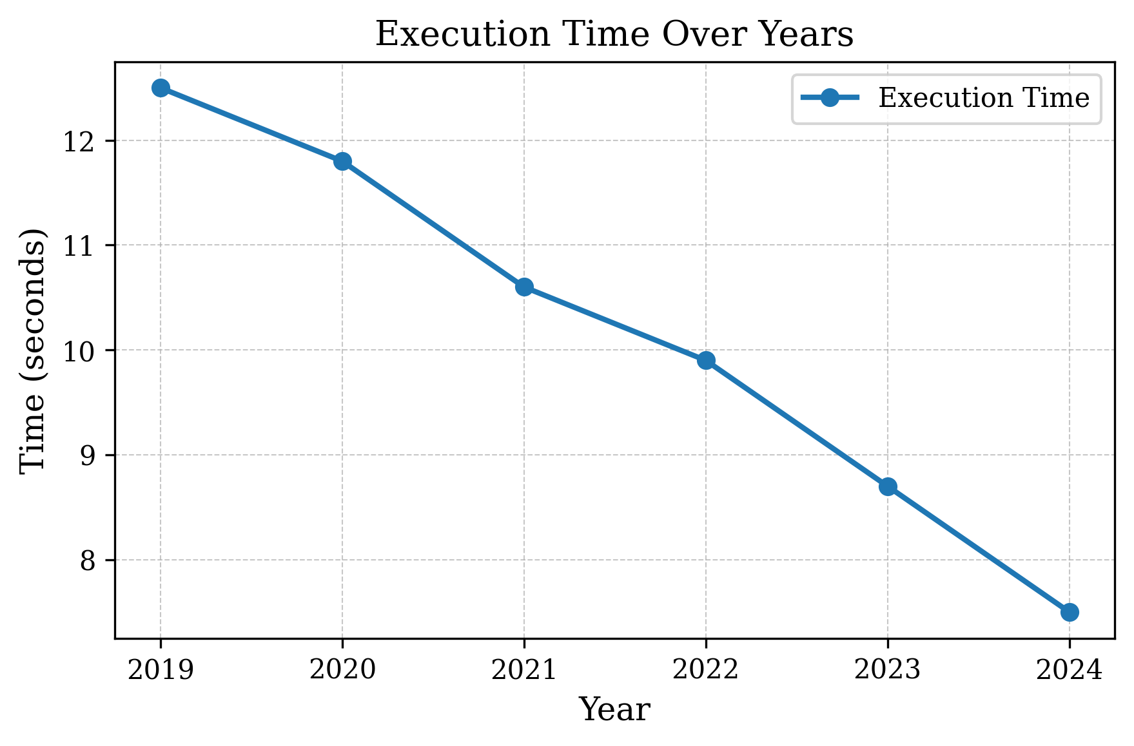
Figure 1: Description of the figure, including all relevant details such as units, sample sizes, and statistical significance markers
2.4 Algorithms
For algorithmic descriptions, present numbered pseudocode steps, e.g.:
1. Initialise y ← 0
2. For each element xᵢ in x: y ← y + f(xᵢ, θ)
3. Return y
3. Results
Present the results in the same logical order as the methods, so that each result connects clearly to the procedure that produced it. Use tables and figures to convey quantitative findings, and reserve the prose for interpretation, comparison, and explanation. Do not duplicate information across a table and a figure; pick the form that best suits the message.
State results with appropriate precision: report uncertainties, sample sizes, and statistical significance where relevant. Avoid claims that the data do not support, and clearly distinguish between findings that are statistically significant and findings that are merely suggestive of a trend.
4. Discussion
The discussion interprets the results in the context of the prior literature, addresses the implications of the findings, acknowledges the limitations of the study, and identifies avenues for future research. Begin by stating the key findings in plain language. Compare these findings with the prior literature, identifying agreements and disagreements and offering possible explanations for any discrepancies.
Limitations should be addressed candidly. Every study has limitations, and acknowledging them strengthens rather than weakens the contribution. Possible limitations include sample size and composition, methodological constraints, scope of generalisation, and assumptions made in the analysis.
5. Conclusions
The conclusions section briefly restates the principal findings and their significance, without simply repeating the results. State the broader contribution of the work to the field, the implications for practice or policy where relevant, and the most promising directions for follow-up research. Keep this section short: typically one to three paragraphs.
Acknowledgement
The authors thank colleagues at Institution Name for helpful discussions, and the staff of Facility Name for technical support during the experimental work.
Declaration of Competing Interests
The authors declare no known competing financial interests or personal relationships that could have appeared to influence the work reported in this paper.
Funding Declaration
This research did not receive any specific grant from funding agencies in the public, commercial, or not-for-profit sectors.
Data Availability Statement
The data that support the findings of this study are available from the corresponding author upon reasonable request.
Use of Generative Artificial Intelligence
The authors declare that no generative artificial intelligence tools were used in the preparation of this manuscript.
Author Contributions
First A. Author: Conceptualization, Methodology, Investigation, Writing – original draft.
Second B. Author: Conceptualization, Supervision, Funding acquisition, Writing – review & editing.
Third C. Author: Software, Formal analysis, Data curation, Visualization, Writing – review & editing.
References
[1] Smith, J. and Doe, J., “A Novel Approach to Intelligent Computation Systems,” Journal of Advanced Intelligent Computing and Informatics, vol. 1, no. 1, pp. 12–22, 2024.
[2] Miller, R., Mechanical and Management Insights, 2nd ed. New York, NY, USA: Example Press, 2018.

